

Financial Management System with Machine Learning Support

Chapter 1

Caleigh Susan Anak Jeffry

Bachelor of Software Engineering with Honours
2025
Table of Contents
Contents
1.1 Introduction 1
1.2 Problem Statement 1
1.3 Scope 3
1.4 Aims and Objective 3
1.5 Brief Methodology 4
1.6 Significance of Project 5
1.7 Project Schedule 6
1.8 Expected Outcome 7
1.9 Project Outline 8
1.10 Chapter Summary 8
1.11 References 9

1.1 Introduction
Managing personal finances effectively as a student is an essential life skill to preserve financial stability and sustain long-term growth. Nowadays, students often use digital transactions which leads to problem when it comes to organize their daily expenses and struggle to control their spending. This is because it is harder to track daily expenses when it comes to cashless payment as it has less emotional impact of spending. This difficulty is further compounded for those who is sharing their daily expenses with friends. Shared expenses encourage informal and manual tracking habits that lead to confusion and delay payment. Hence, this project introduces Spendette, a web application expense analyser designed to address these issues by integrating personal and group finance management within a single platform. Spendette allows users to manage their daily expenditures while managing shared expenses for various purposes such as accommodation, trips, or group activities. This financial management system promotes transparency by ensuring that all the users clearly understand their financial responsibilities. Furthermore, Spendette incorporates Machine Learning to analyse users’ historical spending data, provide personalized budgeting recommendations and detect unusual or excessive expenses. This digital approach enables users to nurture better financial habits. The system also features monthly spending trends to enhance users’ understanding of their financial behaviour. By integrating personal and shared financial management with predictive insights, Spendette offers an approach to financial organization that promotes responsible spending and strengthens financial literacy among its users.

Problem Statement
University students often lack the knowledge and experience needed to manage their finances, leading to a poor financial decisions and financial stress that can affect their mental health and wellbeing. (Cappelli et al., 2024). This issue frequently happens among students that face difficulties in managing their financial efficiently especially tracking both of their personal and shared expenses. In addition, Irby (2024) mentioned that frequent small purchases can accumulate unexpectedly and result in budget overruns, therefore, systematically tracking expenses through receipt collection and categorized spending records enables individuals to identify and manage areas of excessive expenditure more effectively. Students need an automated financial management system to track their daily spending accurately and improve their financial decision. Manually tracking their spending and budget can leads to a range of problem such as below:
- Difficulty in expense tracking: Many students face challenges in efficiently managing both personal and shared expenses due to the lack of exposure to organized tracking system. With the rise of cashless transactions such as e-wallet and online banking, students may forget or overlook small purchases that accumulate over time. Without an automated system, manual tracking can be time-consuming, especially when expenses are split among several people. This lack of clarity can lead to overspending, delayed payments and prone to errors.
- Limited budget control and financial awareness: Many students have a strict budget constraint. Without integrated tracking and analytic tools, students often struggle to monitor their spending behaviour and maintain financial discipline within their budget. The absence of real-time tools makes it difficult to identify spending patterns that will make students unknowingly prioritize short-term satisfaction such as dining out, shopping, or entertainment over essential needs like transportation, academic materials, or savings. This lack of visibility often results in poor financial decisions that can cause stress or long-term financial consequences.
- Challenges in managing shared financial responsibilities: Group expenses like rent, utilities and groceries require a transparent and systematic platform for tracking individual contributions in shared student expenses. Without an automated system, students often rely on manual methods such as chat messages, verbal reminders or manually updated spreadsheet. This can easily lead to confusion, miscalculations and delay payments. This project would minimize the issues by offering automated tracking and clear transaction histories.

Scope
The scopes of Spendette, a financial management system project, define the system boundaries by outlining the essential features and functionalities that support students in managing both personal and shared expenses. The system is designed to be secure, intelligent, and user-friendly, with the following key components:
- System Boundaries
- User Authentication: This feature restricts access to authorized users only as a step to safeguarding sensitive financial information and preventing unauthorized manipulation of records.
- Financial Management: This feature enables users to log their daily expenses, organize budget and manage shared expenses with peers. This feature also helps users to visualize their cash flow and maintain control over their budget.
- Data Visualization Tools: This feature allows users interpret their spending trends and budget usage by using data visualization tools.
- Machine Learning Integration: This Machine Learning Model analyse users’ historical spending patterns, offer personalized budget suggestions and detect overspending.
- User Interface: The system features a clean and intuitive interface designed to ensure that users can easily access key features, input data and interpret financial insights without requiring technical expertise.
- Type of User
Primary user of Spendette Web Application will include:
- University students who need a simple and effective system to manage personal and shared expenses.

Aims and Objective
The main reason to conduct this project generally is to develop an automated system to help users track their daily expenses and provide a clear summary of their budget usage. This project addresses the financial management challenges by offering a digital solution for its user to make informed financial choices, avoid overspending and build healthier budgeting routines over time. Below is a detailed description of each aim and objective:
- To develop a responsive web application that enables users to record, manage and monitor both personal and shared financial transactions to ensure accuracy and transparency - This system allows users to efficiently track and organize their expenses and ensures accessibility across multiple devices. In addition to providing basic transaction recording, the system will have a responsive design to ensures users convenience and absolute access whether users are on a phone, tablet or desktop.
- To generate clear financial summaries and balance sheets that assist users in monitoring their spending effectively - This project aims to provide users with visual and organized representations of their financial data by generating summaries and balance sheets. It helps users make informed decisions, track savings goals, and maintain financial discipline.
- To implement a machine learning model to analyse spending habits and provide personalized budgeting recommendations for improved financial planning - The integration of Machine Learning Model that examining users’ historical spending data, predict potential overspending and offer personalized recommendations. By identifying recurring expenses, the model can generate tailored suggestions to help users optimize their budget and may also alert users when they are close to exceeding their usual spending.

1.5 Brief Methodology
The methodology section outlines the structured approach used to guide completion of this project. Given the integration of machine learning models, it is essential to adopt a flexible and iterative framework. For this reason, the project will be completed using the Agile Methodology, specifically the Scrum framework. Below are the breakdowns of the methodology:
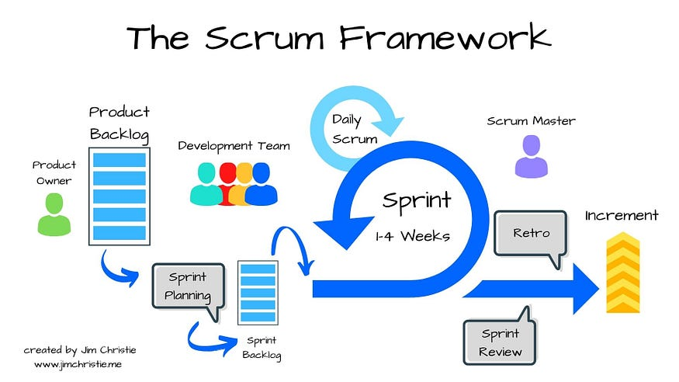
Figure 1 Scrum Framework Model
Source: https://share.google/images/Vv92JcPmkuQuWGzCL
- Product Backlog
A dynamic list of features, requirements, enhancements and fixes and continuously updated to reflect changing needs.
- Sprint Planning
A set of time to identify the goal of the sprint which include what tasks will be completed and how the work will be accomplished.
- Sprint Execution (Development Phase)
A structured process to deliver incremental value through planned iterations, continuous improvement and adaptive planning to efficiently achieve project goals.
- Sprint Review
To demonstrate completed work, gathers feedback, ensures alignment with the product vision and identifies improvements to promote continuous improvement.
- Sprint Retrospective
To evaluate past sprint and create a plan to address areas of improvement for the future.
- Product Increment
A new developed or refined feature that is created at the end of each sprint.

1.6 Significance of Project
The significance of Financial Management System with Machine Learning Support project that introduces Spendette lies in its potential to promote financial awareness and responsible money management among students. Through Machine Learning, the system provides personalized recommendations, empowering users to make smarter financial decisions and develop sustainable financial habits. Below is the significance of the project:
- Promotes Financial Awareness and Responsibility.
The project helps users better understand their spending behaviour by tracking both personal and shared expenses. By recording daily transactions, users become more conscious of their financial habits which avoid unnecessary expenses. Over time, this promotes a sense of responsibility and discipline in managing finances.
- Enhances Transparency in Shared Financial Management.
This project promotes transparency by providing a single platform where users can manage both individual and group expenses. The system minimizes confusion and delays in repayments by keeping a transparent record of all shared financial activities. Each member in a group can view their shared costs in real-time. This fosters a better communication among users who share common financial responsibilities.
- Adaptability with Machine Learning.
By integrating Machine Learning, the system gains the ability to analyse users’ historical spending patterns. This feature allows Spendette to offer personalized budgeting recommendations that align with each user’s financial behaviour. This adaptability not only enhances the functionality of the system but also empowers users to make smarter financial decisions.

1.7 Project Schedule
The project is expected to be completed within two semesters following the course Final Year Project I and Final Year Project II.
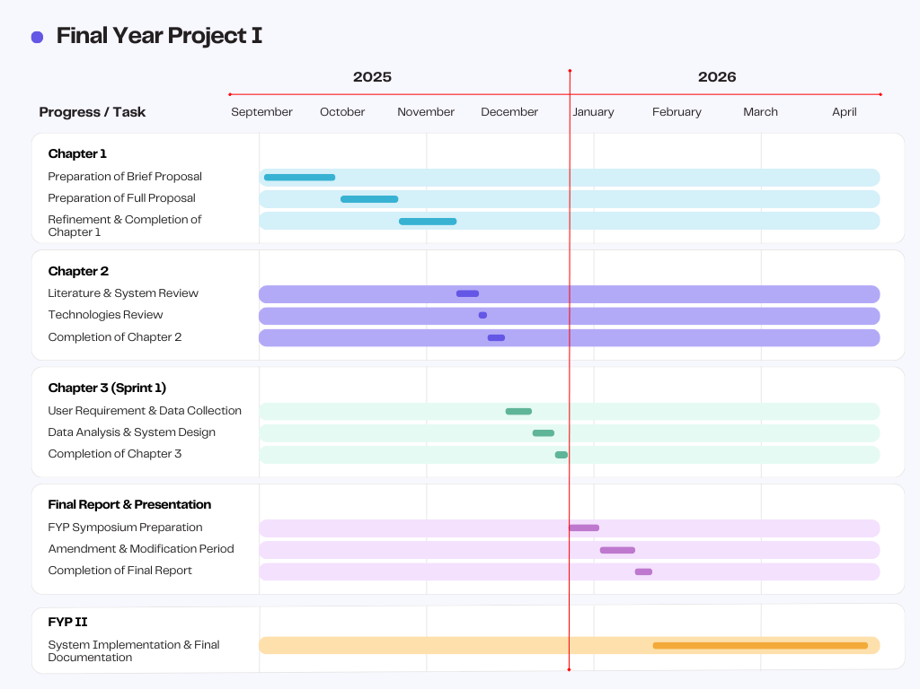
Figure 2 Gantt Chart for FYP 1

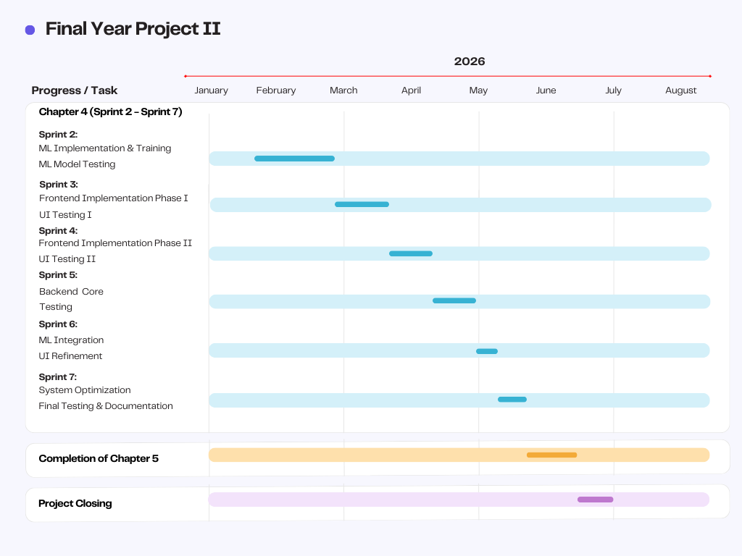
Figure 2 Gantt Chart for FYP 2

1.8 Expected Outcome
The expected outcomes of the Financial Management System with Machine Learning Support project are designed to ensure that the implementation of the system meets the needs of user experience and overall efficiency. These outcomes highlight the improvements in financial tracking accuracy and intelligent budgeting support to ensure the system delivers meaningful value to its users. Below is the detailed description of each expected outcome:
- A fully functional web application financial management system capable of monitoring both personal and shared expenses of an individual.
This outcome focuses on developing a responsive web application that enables users to manage and track both individual and group financial activities in one platform. By integrating these functions, users can easily organize their finances, avoid duplication of records and maintain a clear overview of their personal and shared spending.
- Comprehensive financial summaries that provide users with clear insights into their spending patterns and financial transactions.
This outcome aims to generate detailed reports and visual summaries that allow users to analyse their financial behaviour effectively. The system will display spending trends, budget usage and monthly comparisons to help users identify overspending habits, manage their budgets more efficiently and make informed decisions to improve financial stability.
- A machine learning model capable of analysing users’ spending habits and generating personalized recommendations to help them plan and manage their finances more effectively.
This outcome emphasizes the implementation of a Machine Learning component that intelligently examines historical spending data to recognize patterns and detect irregularities. Based on these analyses, the system will provide personalized budgeting tips and financial recommendations tailored to each user’s spending behaviour.

Project Outline
Chapter 1: Introduction
Chapter 1 provide the introduction of Financial Management System project and the overview of Spendette. This chapter contains Introduction, Problem Statement, Project Scope, Aims and Objectives, Methodology, Significance of Project, Project Schedule, Expected Outcome, Project Outline and Chapter Summary.
Chapter 2: Literature Review
This second chapter contains the background research of the existed system and the comparison between existed systems and Spendette. With this background research, the weakness and limitation of previous systems are being analysed.
Chapter 3: Methodology
Chapter 3 describe the appropriate software development methodology that will be applied to develop the system. This chapter will explain how the methodology helps in achieving the project objectives and why the methodology was chosen.
Chapter 4: Implementation
This chapter presents the implementation and testing of the proposed system. The implementation phase outlines the development process based on the software requirements identified in the previous chapter.
Chapter 5: Testing
Chapter 5 focuses on the testing of the system, which includes functionality testing, user interface evaluation, and security validation. These tests are carried out to ensure that all system features operate correctly and deliver a smooth user experience.

Chapter Summary
The chapter is organized into several key sections, including the introduction, problem statement, aims and objectives, methodology, project scope, significance of the project, expected outcomes, and the overall project outline. The following chapter will present the literature review, providing a detailed examination of existing studies and theories relevant to this research.

1.11 References
Cappelli, T., Banks, A. P., & Gardner, B. (2024). Understanding money-management behaviour and its potential determinants among undergraduate students: A scoping review. PLoS ONE, 19(8), e0307137. https://doi.org/10.1371/journal.pone.0307137
Irby, L. (2024). 10 simple ways to manage your money better. The Balance. https://www.thebalancemoney.com/ways-to-be-better-with-money-960664
Johri, E., Desai, P., Soni, P., Jain, H., & Sanganeria, N. (2023). Expense Management System. 2023 4th IEEE Global Conference for Advancement in Technology (GCAT), Bangalore, India, 1–6. https://doi.org/10.1109/gcat59970.2023.10353348
SCRUM model for agile methodology. (2017). IEEE Conference Publication | IEEE Xplore. https://ieeexplore.ieee.org/abstract/document/8229928

